Spring Framework Annotations

### **@Required**

This annotation is applied on bean setter methods. Consider a scenario where you need to enforce a required property. The @Required annotation indicates that the affected bean must be populated at configuration time with the required property. Otherwise an exception of type BeanInitializationException is thrown.

### **@Autowired**

This annotation is applied on fields, setter methods, and constructors. The @Autowired annotation injects object dependency implicitly.

When you use @Autowired on fields and pass the values for the fields using the property name, Spring will automatically assign the fields with the passed values.

You can even use @Autowired  on private properties, as shown below. (This is a very poor practice though!)

### **@Qualifier**

This annotation is used along with @Autowired annotation. When you need more control of the dependency injection process, @Qualifier can be used. @Qualifier can be specified on individual constructor arguments or method parameters. This annotation is used to avoid confusion which occurs when you create more than one bean of the same type and want to wire only one of them with a property.

### **@Configuration**

This annotation is used on classes which define beans. @Configuration is an analog for XML configuration file – it is configuration using Java class. Java class annotated with @Configuration is a configuration by itself and will have methods to instantiate and configure the dependencies.

### **@ComponentScan**

This annotation is used with @Configuration annotation to allow Spring to know the packages to scan for annotated components. @ComponentScan is also used to specify base packages using basePackageClasses orbasePackage attributes to scan. If specific packages are not defined, scanning will occur from the package of the class that declares this annotation.

### **@Bean**

This annotation is used at the method level. @Bean annotation works with @Configuration to create Spring beans. As mentioned earlier, @Configuration will have methods to instantiate and configure dependencies. Such methods will be annotated with @Bean. The method annotated with this annotation works as bean ID and it creates and returns the actual bean.

Here is an Example

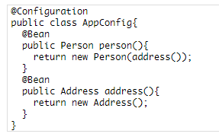

### **@Lazy**

This annotation is used on component classes. By default all autowired dependencies are created and configured at startup. But if you want to initialize a bean lazily, you can use @Lazy annotation over the class. This means that the bean will be created and initialized only when it is first requested for. You can also use this annotation on @Configuration classes. This indicates that all @Bean methods within that @Configuration should be lazily initialized.

### **@Value**

This annotation is used at the field, constructor parameter, and method parameter level. The @Value annotation indicates a default value expression for the field or parameter to initialize the property with. As the @Autowiredannotation tells Spring to inject object into another when it loads your application context, you can also use@Value annotation to inject values from a property file into a bean’s attribute. It supports both #{...} and${...} placeholders.

## Spring Framework Stereotype Annotations

### **@Component**

This annotation is used on classes to indicate a Spring component. The @Component annotation marks the Java class as a bean or say component so that the component-scanning mechanism of Spring can add into the application context.

### **@Controller**

The @Controller  annotation is used to indicate the class is a Spring controller. This annotation can be used to identify controllers for Spring MVC or Spring WebFlux.

### **@Service**

This annotation is used on a class. The @Service marks a Java class that performs some service, such as execute business logic, perform calculations and call external APIs. This annotation is a specialized form of the@Component annotation intended to be used in the service layer.

### **@Repository**

This annotation is used on Java classes which directly access the database. The @Repository annotation works as marker for any class that fulfills the role of repository or Data Access Object.

This annotation has a automatic translation feature. For example, when an exception occurs in the @Repositorythere is a handler for that exception and there is no need to add a try catch block.

### **@EnableAutoConfiguration**

This annotation is usually placed on the main application class. The @EnableAutoConfiguration annotation implicitly defines a base “search package”. This annotation tells Spring Boot to start adding beans based on classpath settings, other beans, and various property settings.

### **@SpringBootApplication**

This annotation is used on the application class while setting up a Spring Boot project. The class that is annotated with the @SpringBootApplication must be kept in the base package. The one thing that the@SpringBootApplication does is a component scan. But it will scan only its sub-packages. As an example, if you put the class annotated with @SpringBootApplication in com.example then @SpringBootApplication will scan all its sub-packages, such as com.example.a, com.example.b, and com.example.a.x.

The @SpringBootApplication is a convenient annotation that adds all the following:

* @Configuration
* @EnableAutoConfiguration
* @ComponentScan

## Spring MVC and REST Annotations

### **@Controller**

This annotation is used on Java classes that play the role of controller in your application. The @Controllerannotation allows autodetection of component classes in the classpath and auto-registering bean definitions for them. To enable autodetection of such annotated controllers, you can add component scanning to your configuration. The Java class annotated with @Controller is capable of handling multiple request mappings.

This annotation can be used with Spring MVC and Spring WebFlux.

### **@RequestMapping**

This annotation is used both at class and method level. The @RequestMapping annotation is used to map web requests onto specific handler classes and handler methods. When @RequestMapping is used on class level it creates a base URI for which the controller will be used. When this annotation is used on methods it will give you the URI on which the handler methods will be executed. From this you can infer that the class level request mapping will remain the same whereas each handler method will have their own request mapping.

Sometimes you may want to perform different operations based on the HTTP method used, even though the request URI may remain the same. In such situations, you can use the method attribute of @RequestMapping with an HTTP method value to narrow down the HTTP methods in order to invoke the methods of your class.

Here is a basic example on how a controller along with request mappings work:

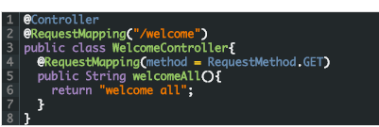

## Request Mapping Basics

In Spring MVC applications, the RequestDispatcher (Front Controller Below) servlet is responsible for routing incoming HTTP requests to handler methods of controllers.

When configuring Spring MVC, you need to specify the mappings between the requests and handler methods.

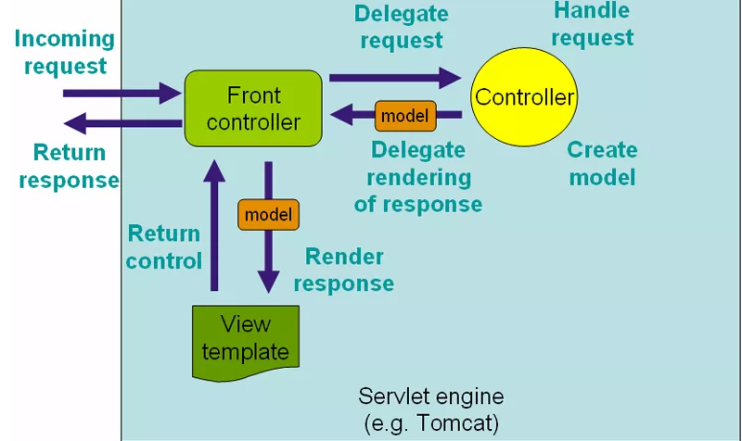

To configure the mapping of web requests, you use the @RequestMapping annotation.

The @RequestMapping annotation can be applied to class-level and/or method-level in a controller.

The class-level annotation maps a specific request path or pattern onto a controller. You can then apply additional method-level annotations to make mappings more specific to handler methods.

Here is an example of the @RequestMapping annotation applied to both class and methods.

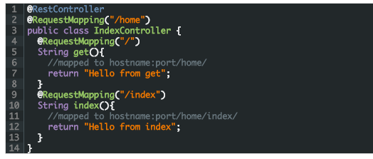

With the preceding code, requests to /home will be handled by get() while request to /home/index will be handled by index().

## @RequestMapping with Multiple URIs

You can have multiple request mappings for a method. For that add one @RequestMapping annotation with a list of values.

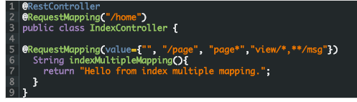

As you can see in this code, @RequestMapping supports wildcards and ant-style paths. For the preceding code, all these URLs will be handled by indexMultipleMapping().

* localhost:8080/home
* localhost:8080/home/
* localhost:8080/home/page
* localhost:8080/home/pageabc
* localhost:8080/home/view/
* localhost:8080/home/view/view

## @RequestMapping with @RequestParam

The @RequestParam annotation is used with @RequestMapping to bind a web request parameter to the parameter of the handler method.

The @RequestParam annotation can be used with or without a value. The value specifies the request param that needs to be mapped to the handler method parameter, as shown in this code snippet.

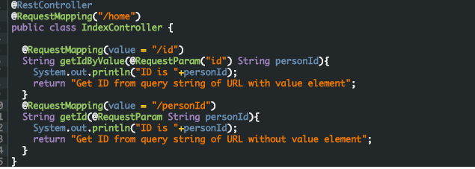

In Line 6 of this code, the request param id will be mapped to the personId parameter personId of thegetIdByValue() handler method.

An example URL is this:  
localhost:8090/home/id?id=5

The value element of @RequestParam can be omitted if the request param and handler method parameter names are same, as shown in Line 11.

An example URL is this:  
localhost:8090/home/personId?personId=5

The required element of @RequestParam defines whether the parameter value is required or not.

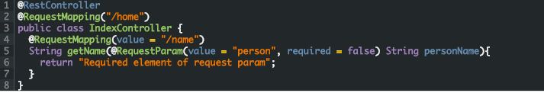

## Using @RequestMapping with HTTP Method

The Spring MVC  @RequestMapping annotation is capable of handling HTTP request methods, such as GET, PUT, POST, DELETE, and PATCH.

By default all requests are assumed to be of HTTP GET type.

In order to define a request mapping with a specific HTTP method, you need to declare the HTTP method in@RequestMapping using the method element as follows.

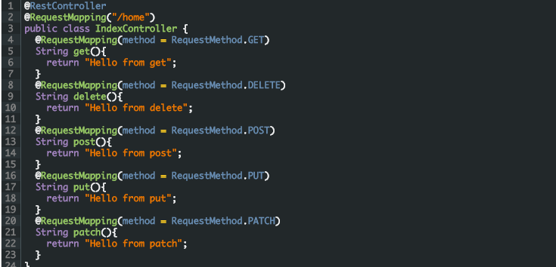

In the code snippet above, the method element of the @RequestMapping annotations indicates the HTTP method type of the HTTP request.

All the handler methods will handle requests coming to the same URL ( /home), but will depend on the HTTP method being used.

For example, a POST request to /home will be handled by the post() method. While a DELETE request to/home will be handled by the delete() method.

You can see how Spring MVC will map the other methods using this same logic.

## Using @RequestMapping with Producible and Consumable

The request mapping types can be narrowed down using the produces and consumes elements of the@RequestMapping annotation.

In order to produce the object in the requested media type, you use the produces element of @RequestMapping in combination with the @ResponseBody annotation.

You can also consume the object with the requested media type using the consumes element of@RequestMapping in combination with the @RequestBody annotation.

The code to use producible and consumable with @RequestMapping is this.

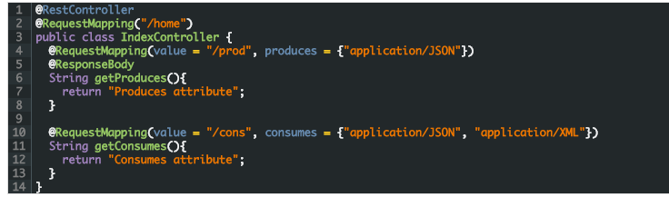

In this code, the getProduces() handler method produces a JSON response. The getConsumes() handler method consumes JSON as well as XML present in requests.

## @RequestMapping with Headers

The @RequestMapping annotation provides a header element to narrow down the request mapping based on headers present in the request.

You can specify the header element as myHeader = myValue.

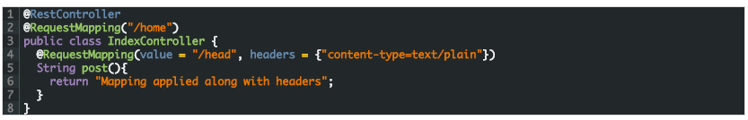In the above code snippet, the headers attribute of the @RequestMapping annotation narrows down the mapping to the post() method. With this, the post() method will handle requests to /home/head whose content-typeheader specifies plain text as the value.

You can also indicate multiple header values like this

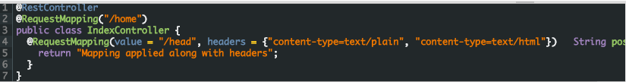

Here it implies that both text/plain as well as text/html are accepted by the post() handler method.

## @RequestMapping with Request Parameters

The params element of the @RequestMapping annotation further helps to narrow down request mapping. Using the params element, you can have multiple handler methods handling requests to the same URL, but with different parameters.

You can define params as myParams = myValue. You can also use the negation operator to specify that a particular parameter value is not supported in the request.

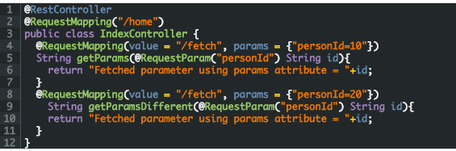  
In this code snippet, both the getParams() and getParamsDifferent() methods will handle requests coming to the same URL ( /home/fetch) but will execute depending on the params element.

For example, when the URL is /home/fetch?id=10 the getParams() handler method will be executed with the id value 10.. For the URL, localhost:8080/home/fetch?personId=20, the getParamsDifferent() handler method gets executed with the id value 20.

## Using @RequestMapping with Dynamic URIs

The @RequestMapping annotation is used in combination with the @PathVaraible annotation to handle dynamic URIs. In this use case, the URI values can act as the parameter of the handler methods in the controller. You can also use regular expressions to only accept the dynamic URI values that match the regular expression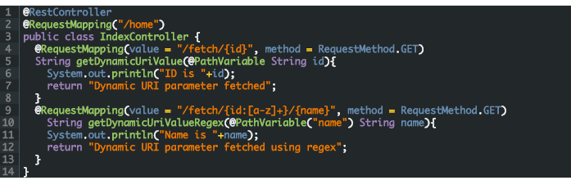

In this code, the method getDynamicUriValue() will execute for a request to localhost:8080/home/fetch/10. Also, the id parameter of the getDynamicUriValue() handler method will be populated with the value 10 dynamically.

The method getDynamicUriValueRegex() will execute for a request to localhost:8080/home/fetch/category/shirt. However, an exception will be thrown for a request to /home/fetch/10/shirt as it does not match the regular expression.

@PathVariable works differently from @RequestParam. You use @RequestParam to obtain the values of the query parameters from the URI. On the other hand, you use @PathVariable to obtain the parameter values from the URI template.

## The @RequestMapping Default Handler Method

In the controller class you can have default handler method that gets executed when there is a request for a default URI.

Here is an example of a default handler method.

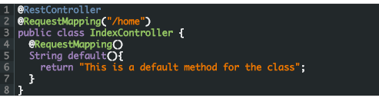

In this code, A request to /home will be handled by the default() method as the annotation does not specify any value.

## @RequestMapping Shortcuts

[Spring 4.3](https://spring.io/blog/2016/06/10/spring-framework-4-3-goes-ga) introduced method-level variants, also known as composed annotations of @RequestMapping. The composed annotations better express the semantics of the annotated methods. They act as wrapper to@RequestMapping and have become the standard ways of defining the endpoints.

For example, @GetMapping is a composed annotation that acts as a shortcut for @RequestMapping(method =RequestMethod.GET).  
The method level variants are:

* @GetMapping
* @PostMapping
* @PutMapping
* @DeleteMapping
* @PatchMapping

The following code shows using the composed annotations.

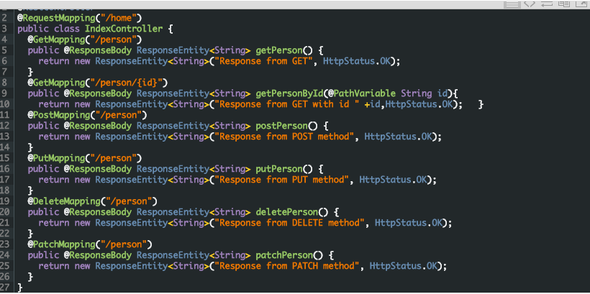

In this code, each of the handler methods are annotated with the composed variants of @RequestMapping. Although, each variant can be interchangeably used with @RequestMapping with the method attribute, it’s considered a best practice to use the composed variant. Primarily because the composed annotations reduce the configuration metadata on the application side and the code is more readable.

## @RequestMapping Conclusion

As you can see in this post, the @RequestMapping  annotation is very versatile. You can use this annotation to configure Spring MVC to handle a variety of use cases. It can be used to configure traditional web page requests, and well as RESTFul web services in Spring MVC.

### **@CookieValue**

This annotation is used at method parameter level. @CookieValue is used as argument of request mapping method. The HTTP cookie is bound to the @CookieValue parameter for a given cookie name. This annotation is used in the method annotated with @RequestMapping.  
Let us consider that the following cookie value is received with a http request:

JSESSIONID=418AB76CD83EF94U85YD34W

To get the value of the cookie, use @CookieValue like this:



### **@CrossOrigin**

This annotation is used both at class and method level to enable cross origin requests. In many cases the host that serves JavaScript will be different from the host that serves the data. In such a case Cross Origin Resource Sharing (CORS) enables cross-domain communication. To enable this communication you just need to add the@CrossOrigin annotation.

By default the @CrossOrigin annotation allows all origin, all headers, the HTTP methods specified in the@RequestMapping annotation and maxAge of 30 min. You can customize the behavior by specifying the corresponding attribute values.

An example to use @CrossOrigin at both controller and handler method levels is this.

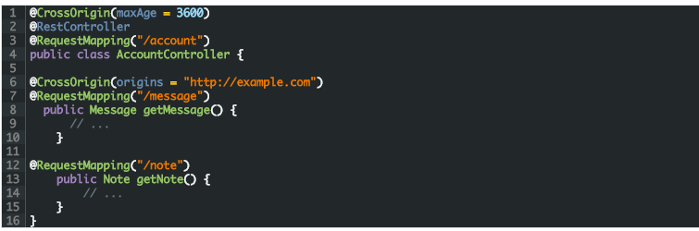

In this example, both getExample() and getNote() methods will have a maxAge of 3600 seconds. Also,getExample() will only allow cross-origin requests from http://example.com, while getNote() will allow cross-origin requests from all hosts.

## Composed @RequestMapping Variants

Spring framework 4.3 introduced the following method-level variants of @RequestMapping annotation to better express the semantics of the annotated methods. Using these annotations have become the standard ways of defining the endpoints. They act as wrapper to @RequestMapping.

These annotations can be used with Spring MVC and Spring WebFlux.



[Spring](https://springframework.guru/category/spring/), [Spring Core](https://springframework.guru/category/spring/spring-core/)

## SPRING FRAMEWORK ANNOTATIONS

[Standard](https://springframework.guru/spring-framework-annotations/)[September 20, 2017](https://springframework.guru/2017/09/20/)by [jt](https://springframework.guru/author/jt/)[15 Comments](https://springframework.guru/spring-framework-annotations/#comments)

The Java Programming language provided support for Annotations from Java 5.0. Leading Java frameworks were quick to adopt annotations and the Spring Framework started using annotations from the release 2.5. Due to the way they are defined, annotations provide a lot of context in their declaration.

Prior to annotations, the behavior of the Spring Framework was largely controlled through XML configuration. Today, the use of annotations provide us tremendous capabilities in how we configure the behaviours of the Spring Framework.

In this post, we’ll take a look at the annotations available in the Spring Framework.

## Core Spring Framework Annotations

### **@Required**

This annotation is applied on bean setter methods. Consider a scenario where you need to enforce a required property. The @Required annotation indicates that the affected bean must be populated at configuration time with the required property. Otherwise an exception of type BeanInitializationException is thrown.

### **@Autowired**

This annotation is applied on fields, setter methods, and constructors. The @Autowired annotation injects object dependency implicitly.

When you use @Autowired on fields and pass the values for the fields using the property name, Spring will automatically assign the fields with the passed values.

You can even use @Autowired  on private properties, as shown below. (This is a very poor practice though!)



|  |  |
| --- | --- |
| **1**  **2**  **3**  **4**  **5** | **public class Customer {**  **@Autowired**  **private Person person;**  **private int type;**  **}** |

When you use @Autowired on setter methods, Spring tries to perform the by Type autowiring on the method. You are instructing Spring that it should initiate this property using setter method where you can add your custom code, like initializing any other property with this property.



|  |  |
| --- | --- |
| **1**  **2**  **3**  **4**  **5**  **6**  **7** | **public class Customer {**  **private Person person;**  **@Autowired**  **public void setPerson (Person person) {**  **this.person=person;**  **}**  **}** |

Consider a scenario where you need instance of class A, but you do not store A in the field of the class. You just use A to obtain instance of B, and you are storing B in this field. In this case setter method autowiring will better suite you. You will not have class level unused fields.

When you use @Autowired on a constructor, constructor injection happens at the time of object creation. It indicates the constructor to autowire when used as a bean. One thing to note here is that only one constructor of any bean class can carry the @Autowired annotation.



|  |  |
| --- | --- |
| **1**  **2**  **3**  **4**  **5**  **6**  **7**  **8** | **@Component**  **public class Customer {**  **private Person person;**  **@Autowired**  **public Customer (Person person) {**  **this.person=person;**  **}**  **}** |

NOTE: As of Spring 4.3, @Autowired  became optional on classes with a single constructor. In the above example, Spring would still inject an instance of the Person  class if you omitted the @Autowired  annotation.

### **@Qualifier**

This annotation is used along with @Autowired annotation. When you need more control of the dependency injection process, @Qualifier can be used. @Qualifier can be specified on individual constructor arguments or method parameters. This annotation is used to avoid confusion which occurs when you create more than one bean of the same type and want to wire only one of them with a property.

Consider an example where an interface BeanInterface is implemented by two beans BeanB1 and BeanB2.



|  |  |
| --- | --- |
| **1**  **2**  **3**  **4**  **5**  **6**  **7**  **8** | **@Component**  **public class BeanB1 implements BeanInterface {**  **//**  **}**  **@Component**  **public class BeanB2 implements BeanInterface {**  **//**  **}** |

Now if BeanA autowires this interface, Spring will not know which one of the two implementations to inject.  
One solution to this problem is the use of the @Qualifier annotation.



|  |  |
| --- | --- |
| **1**  **2**  **3**  **4**  **5**  **6**  **7** | **@Component**  **public class BeanA {**  **@Autowired**  **@Qualifier("beanB2")**  **private BeanInterface dependency;**  **...**  **}** |

With the @Qualifier annotation added, Spring will now know which bean to autowire where beanB2 is the name of BeanB2.

### **@Configuration**

This annotation is used on classes which define beans. @Configuration is an analog for XML configuration file – it is configuration using Java class. Java class annotated with @Configuration is a configuration by itself and will have methods to instantiate and configure the dependencies.

Here is an example:



|  |  |
| --- | --- |
| **1**  **2**  **3**  **4**  **5**  **6**  **7**  **8**  **9**  **10**  **11**  **12**  **13**  **14**  **15**  **16** | **@Configuration**  **public class DataConfig{**  **@Bean**  **public DataSource source(){**  **DataSource source = new OracleDataSource();**  **source.setURL();**  **source.setUser();**  **return source;**  **}**  **@Bean**  **public PlatformTransactionManager manager(){**  **PlatformTransactionManager manager = new BasicDataSourceTransactionManager();**  **manager.setDataSource(source());**  **return manager;**  **}**  **}** |

### **@ComponentScan**

This annotation is used with @Configuration annotation to allow Spring to know the packages to scan for annotated components. @ComponentScan is also used to specify base packages using basePackageClasses orbasePackage attributes to scan. If specific packages are not defined, scanning will occur from the package of the class that declares this annotation.

Checkout this [post](https://springframework.guru/spring-component-scan/) for an in depth look at the Component Scan annotation.

### **@Bean**

This annotation is used at the method level. @Bean annotation works with @Configuration to create Spring beans. As mentioned earlier, @Configuration will have methods to instantiate and configure dependencies. Such methods will be annotated with @Bean. The method annotated with this annotation works as bean ID and it creates and returns the actual bean.

Here is an example:



|  |  |
| --- | --- |
| **1**  **2**  **3**  **4**  **5**  **6**  **7**  **8**  **9**  **10**  **11** | **@Configuration**  **public class AppConfig{**  **@Bean**  **public Person person(){**  **return new Person(address());**  **}**  **@Bean**  **public Address address(){**  **return new Address();**  **}**  **}** |

### **@Lazy**

This annotation is used on component classes. By default all autowired dependencies are created and configured at startup. But if you want to initialize a bean lazily, you can use @Lazy annotation over the class. This means that the bean will be created and initialized only when it is first requested for. You can also use this annotation on @Configuration classes. This indicates that all @Bean methods within that @Configuration should be lazily initialized.

### **@Value**

This annotation is used at the field, constructor parameter, and method parameter level. The @Value annotation indicates a default value expression for the field or parameter to initialize the property with. As the @Autowiredannotation tells Spring to inject object into another when it loads your application context, you can also use@Value annotation to inject values from a property file into a bean’s attribute. It supports both #{...} and${...} placeholders.

## Spring Framework Stereotype Annotations

### **@Component**

This annotation is used on classes to indicate a Spring component. The @Component annotation marks the Java class as a bean or say component so that the component-scanning mechanism of Spring can add into the application context.

### **@Controller**

The @Controller  annotation is used to indicate the class is a Spring controller. This annotation can be used to identify controllers for Spring MVC or Spring WebFlux.

### **@Service**

This annotation is used on a class. The @Service marks a Java class that performs some service, such as execute business logic, perform calculations and call external APIs. This annotation is a specialized form of the@Component annotation intended to be used in the service layer.

### **@Repository**

This annotation is used on Java classes which directly access the database. The @Repository annotation works as marker for any class that fulfills the role of repository or Data Access Object.

This annotation has a automatic translation feature. For example, when an exception occurs in the @Repositorythere is a handler for that exception and there is no need to add a try catch block.

## Spring Boot Annotations

### **@EnableAutoConfiguration**

This annotation is usually placed on the main application class. The @EnableAutoConfiguration annotation implicitly defines a base “search package”. This annotation tells Spring Boot to start adding beans based on classpath settings, other beans, and various property settings.

### **@SpringBootApplication**

This annotation is used on the application class while setting up a Spring Boot project. The class that is annotated with the @SpringBootApplication must be kept in the base package. The one thing that the@SpringBootApplication does is a component scan. But it will scan only its sub-packages. As an example, if you put the class annotated with @SpringBootApplication in com.example then @SpringBootApplication will scan all its sub-packages, such as com.example.a, com.example.b, and com.example.a.x.

The @SpringBootApplication is a convenient annotation that adds all the following:

* @Configuration
* @EnableAutoConfiguration
* @ComponentScan

## Spring MVC and REST Annotations

### **@Controller**

This annotation is used on Java classes that play the role of controller in your application. The @Controllerannotation allows autodetection of component classes in the classpath and auto-registering bean definitions for them. To enable autodetection of such annotated controllers, you can add component scanning to your configuration. The Java class annotated with @Controller is capable of handling multiple request mappings.

This annotation can be used with Spring MVC and Spring WebFlux.

### **@RequestMapping**

This annotation is used both at class and method level. The @RequestMapping annotation is used to map web requests onto specific handler classes and handler methods. When @RequestMapping is used on class level it creates a base URI for which the controller will be used. When this annotation is used on methods it will give you the URI on which the handler methods will be executed. From this you can infer that the class level request mapping will remain the same whereas each handler method will have their own request mapping.

Sometimes you may want to perform different operations based on the HTTP method used, even though the request URI may remain the same. In such situations, you can use the method attribute of @RequestMapping with an HTTP method value to narrow down the HTTP methods in order to invoke the methods of your class.

Here is a basic example on how a controller along with request mappings work:



|  |  |
| --- | --- |
| **1**  **2**  **3**  **4**  **5**  **6**  **7**  **8** | **@Controller**  **@RequestMapping("/welcome")**  **public class WelcomeController{**  **@RequestMapping(method = RequestMethod.GET)**  **public String welcomeAll(){**  **return "welcome all";**  **}**  **}** |

In this example only GET requests to /welcome is handled by the welcomeAll() method.

This annotation also can be used with Spring MVC and Spring WebFlux.

The @RequestMapping  annotation is very versatile. Please see my in depth post on [Request Mapping bere](https://springframework.guru/spring-requestmapping-annotation/).

### **@CookieValue**

This annotation is used at method parameter level. @CookieValue is used as argument of request mapping method. The HTTP cookie is bound to the @CookieValue parameter for a given cookie name. This annotation is used in the method annotated with @RequestMapping.  
Let us consider that the following cookie value is received with a http request:

JSESSIONID=418AB76CD83EF94U85YD34W

To get the value of the cookie, use @CookieValue like this:



|  |  |
| --- | --- |
| **1**  **2**  **3** | **@RequestMapping("/cookieValue")**  **public void getCookieValue(@CookieValue "JSESSIONID" String cookie){**  **}** |

### **@CrossOrigin**

This annotation is used both at class and method level to enable cross origin requests. In many cases the host that serves JavaScript will be different from the host that serves the data. In such a case Cross Origin Resource Sharing (CORS) enables cross-domain communication. To enable this communication you just need to add the@CrossOrigin annotation.

By default the @CrossOrigin annotation allows all origin, all headers, the HTTP methods specified in the@RequestMapping annotation and maxAge of 30 min. You can customize the behavior by specifying the corresponding attribute values.

An example to use @CrossOrigin at both controller and handler method levels is this.



|  |  |
| --- | --- |
| **1**  **2**  **3**  **4**  **5**  **6**  **7**  **8**  **9**  **10**  **11**  **12**  **13**  **14**  **15**  **16** | **@CrossOrigin(maxAge = 3600)**  **@RestController**  **@RequestMapping("/account")**  **public class AccountController {**    **@CrossOrigin(origins = "http://example.com")**  **@RequestMapping("/message")**  **public Message getMessage() {**  **// ...**  **}**    **@RequestMapping("/note")**  **public Note getNote() {**  **// ...**  **}**  **}** |

In this example, both getExample() and getNote() methods will have a maxAge of 3600 seconds. Also,getExample() will only allow cross-origin requests from http://example.com, while getNote() will allow cross-origin requests from all hosts.

## Composed @RequestMapping Variants

Spring framework 4.3 introduced the following method-level variants of @RequestMapping annotation to better express the semantics of the annotated methods. Using these annotations have become the standard ways of defining the endpoints. They act as wrapper to @RequestMapping.

These annotations can be used with Spring MVC and Spring WebFlux.

### **@GetMapping**

This annotation is used for mapping HTTP GET requests onto specific handler methods. @GetMapping is a composed annotation that acts as a shortcut for @RequestMapping(method = RequestMethod.GET)

### **@PostMapping**

This annotation is used for mapping HTTP POST requests onto specific handler methods. @PostMapping is a composed annotation that acts as a shortcut for @RequestMapping(method = RequestMethod.POST)

### **@PutMapping**

This annotation is used for mapping HTTP PUT requests onto specific handler methods. @PutMapping is a composed annotation that acts as a shortcut for @RequestMapping(method = RequestMethod.PUT)

### **@PatchMapping**

This annotation is used for mapping HTTP PATCH requests onto specific handler methods. @PatchMapping is a composed annotation that acts as a shortcut for @RequestMapping(method = RequestMethod.PATCH)

### **@DeleteMapping**

This annotation is used for mapping HTTP DELETE requests onto specific handler methods. @DeleteMapping is a composed annotation that acts as a shortcut for @RequestMapping(method = RequestMethod.DELETE)

### **@ExceptionHandler**

This annotation is used at method levels to handle exception at the controller level. The @ExceptionHandlerannotation is used to define the class of exception it will catch. You can use this annotation on methods that should be invoked to handle an exception. The @ExceptionHandler values can be set to an array of Exception types. If an exception is thrown that matches one of the types in the list, then the method annotated with matching @ExceptionHandler will be invoked.

### **@InitBinder**

This annotation is a method level annotation that plays the role of identifying the methods which initialize theWebDataBinder - a DataBinder that binds the request parameter to JavaBean objects. To customise request parameter data binding , you can use @InitBinder annotated methods within our controller. The methods annotated with @InitBinder all argument types that handler methods support.  
The @InitBinder annotated methods will get called for each HTTP request if you don’t specify the value element of this annotation. The value element can be a single or multiple form names or request parameters that the init binder method is applied to.

### **@Mappings and @Mapping**

This annotation is used on fields. The @Mapping annotation is a meta annotation that indicates a web mapping annotation. When mapping different field names, you need to configure the source field to its target field and to do that you have to add the @Mappings annotation. This annotation accepts an array of @Mapping having the source and the target fields.

### **@MatrixVariable**

This annotation is used to annotate request handler method arguments so that Spring can inject the relevant bits of matrix URI. Matrix variables can appear on any segment each separated by a semicolon. If a URL contains matrix variables, the request mapping pattern must represent them with a URI template. The@MatrixVariable annotation ensures that the request is matched with the correct matrix variables of the URI.

### **@PathVariable**

This annotation is used to annotate request handler method arguments. The @RequestMapping annotation can be used to handle dynamic changes in the URI where certain URI value acts as a parameter. You can specify this parameter using a regular expression. The @PathVariable annotation can be used declare this parameter.

### **@RequestAttribute**

This annotation is used to bind the request attribute to a handler method parameter. Spring retrieves the named attributes value to populate the parameter annotated with @RequestAttribute. While the @RequestParamannotation is used bind the parameter values from query string, the @RequestAttribute is used to access the objects which have been populated on the server side.

### **@RequestBody**

This annotation is used to annotate request handler method arguments. The @RequestBody annotation indicates that a method parameter should be bound to the value of the HTTP request body. The HttpMessageConveter is responsible for converting from the HTTP request message to object.

### **@RequestHeader**

This annotation is used to annotate request handler method arguments. The @RequestHeader annotation is used to map controller parameter to request header value. When Spring maps the request, @RequestHeader checks the header with the name specified within the annotation and binds its value to the handler method parameter. This annotation helps you to get the header details within the controller class.

### **@RequestParam**

This annotation is used to annotate request handler method arguments. Sometimes you get the parameters in the request URL, mostly in GET requests. In that case, along with the @RequestMapping annotation you can use the @RequestParam annotation to retrieve the URL parameter and map it to the method argument. The@RequestParam annotation is used to bind request parameters to a method parameter in your controller.

### **@RequestPart**

This annotation is used to annotate request handler method arguments. The @RequestPart annotation can be used instead of @RequestParam to get the content of a specific multipart and bind to the method argument annotated with @RequestPart. This annotation takes into consideration the “Content-Type” header in the multipart(request part).

### **@ResponseBody**

This annotation is used to annotate request handler methods. The @ResponseBody annotation is similar to the@RequestBody annotation. The @ResponseBody annotation indicates that the result type should be written straight in the response body in whatever format you specify like JSON or XML. Spring converts the returned object into a response body by using the HttpMessageConveter.

### **@ResponseStatus**

This annotation is used on methods and exception classes. @ResponseStatus marks a method or exception class with a status code and a reason that must be returned. When the handler method is invoked the status code is set to the HTTP response which overrides the status information provided by any other means. A controller class can also be annotated with @ResponseStatus which is then inherited by all @RequestMapping methods.

### **@ControllerAdvice**

This annotation is applied at the class level. As explained earlier, for each controller you can use@ExceptionHandler on a method that will be called when a given exception occurs. But this handles only those exception that occur within the controller in which it is defined. To overcome this problem you can now use the@ControllerAdvice annotation. This annotation is used to define @ExceptionHandler, @InitBinder and@ModelAttribute methods that apply to all @RequestMapping methods. Thus if you define the @ExceptionHandlerannotation on a method in @ControllerAdvice class, it will be applied to all the controllers.

### **@RestController**

This annotation is used at the class level. The @RestController annotation marks the class as a controller where every method returns a domain object instead of a view. By annotating a class with this annotation you no longer need to add @ResponseBody to all the RequestMapping method. It means that you no more use view-resolvers or send html in response. You just send the domain object as HTTP response in the format that is understood by the consumers like JSON.

@RestController  is a convenience annotation which combines @Controller  and @ResponseBody .

### **@RestControllerAdvice**

This annotation is applied on Java classes. @RestControllerAdvice is a convenience annotation which combines @ControllerAdvice and @ResponseBody. This annotation is used along with the @ExceptionHandler annotation to handle exceptions that occur within the controller.

### **@SessionAttribute**

This annotation is used at method parameter level. The @SessionAttribute annotation is used to bind the method parameter to a session attribute. This annotation provides a convenient access to the existing or permanent session attributes.

### **@SessionAttributes**

This annotation is applied at type level for a specific handler. The @SessionAtrributes annotation is used when you want to add a JavaBean object into a session. This is used when you want to keep the object in session for short lived. @SessionAttributes is used in conjunction with @ModelAttribute.  
Consider this example.

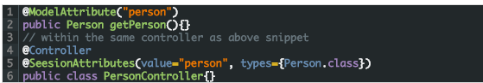

The @ModelAttribute name is assigned to the @SessionAttributes as value. The @SessionAttributes has two elements. The value element is the name of the session in the model and the types element is the type of session attributes in the model.

## Spring Cloud Annotations

### **@EnableConfigServer**

This annotation is used at the class level. When developing a project with a number of services, you need to have a centralized and straightforward manner to configure and retrieve the configurations about all the services that you are going to develop. One advantage of using a centralized config server is that you don’t need to carry the burden of remembering where each configuration is distributed across multiple and distributed components.

You can use Spring cloud’s @EnableConfigServer annotation to start a config server that the other applications can talk to.

### **@EnableEurekaServer**

This annotation is applied to Java classes. One problem that you may encounter while decomposing your application into microservices is that, it becomes difficult for every service to know the address of every other service it depends on. There comes the discovery service which is responsible for tracking the locations of all other microservices.  
Netflix’s Eureka is an implementation of a discovery server and integration is provided by Spring Boot. Spring Boot has made it easy to design a Eureka Server by just annotating the entry class with @EnableEurekaServer.

### **@EnableDiscoveryClient**

This annotation is applied to Java classes. In order to tell any application to register itself with Eureka you just need to add the @EnableDiscoveryClientannotation to the application entry point. The application that’s now registered with Eureka uses the Spring Cloud Discovery Client abstraction to interrogate the registry for its own host and port.

### **@EnableCircuitBreaker**

This annotation is applied on Java classes that can act as the circuit breaker. The circuit breaker pattern can allow a micro service continue working when a related service fails, preventing the failure from cascading. This also gives the failed service a time to recover.

The class annotated with @EnableCircuitBreaker will monitor, open, and close the circuit breaker.

### **@HystrixCommand**

This annotation is used at the method level. Netflix’s Hystrix library provides the implementation of Circuit Breaker pattern. When you apply the circuit breaker to a method, Hystrix watches for the failures of the method. Once failures build up to a threshold, Hystrix opens the circuit so that the subsequent calls also fail. Now Hystrix redirects calls to the method and they are passed to the specified fallback methods.  
Hystrix looks for any method annotated with the @HystrixCommand annotation and wraps it into a proxy connected to a circuit breaker so that Hystrix can monitor it.

Consider the following example:

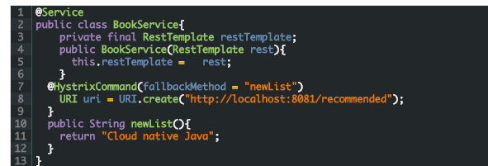

Here @HystrixCommand is applied to the original method bookList(). The @HystrixCommand annotation has newList as the fallback method. So for some reason if Hystrix opens the circuit on bookList(), you will have a placeholder book list ready for the users.

## Spring Framework DataAccess Annotations

### **@Transactional**

This annotation is placed before an interface definition, a method on an interface, a class definition, or a public method on a class. The mere presence of @Transactional is not enough to activate the transactional behaviour. The @Transactional is simply a metadata that can be consumed by some runtime infrastructure. This infrastructure uses the metadata to configure the appropriate beans with transactional behaviour.

The annotation further supports configuration like:

* The Propagation type of the transaction
* The Isolation level of the transaction
* A timeout for the operation wrapped by the transaction
* A read only flag - a hint for the persistence provider that the transaction must be read only  
  The rollback rules for the transaction

## Cache-Based Annotations

### **@Cacheable**

This annotation is used on methods. The simplest way of enabling the cache behaviour for a method is to annotate it with @Cacheable and parameterize it with the name of the cache where the results would be stored



In the snippet above , the method getAddress is associated with the cache named addresses. Each time the method is called, the cache is checked to see whether the invocation has been already executed and does not have to be repeated.

### **@CachePut**

This annotation is used on methods. Whenever you need to update the cache without interfering the method execution, you can use the @CachePut annotation. That is, the method will always be executed and the result cached.



Using @CachePut and @Cacheable on the same method is strongly discouraged as the former forces the execution in order to execute a cache update, the latter causes the method execution to be skipped by using the cache.

### **@CacheEvict**

This annotation is used on methods. It is not that you always want to populate the cache with more and more data. Sometimes you may want remove some cache data so that you can populate the cache with some fresh values. In such a case use the @CacheEvict annotation.



Here an additional element allEntries is used along with the cache name to be emptied. It is set to true so that it clears all values and prepares to hold new data.

### **@CacheConfig**

This annotation is a class level annotation. The @CacheConfig annotation helps to streamline some of the cache information at one place. Placing this annotation on a class does not turn on any caching operation. This allows you to store the cache configuration at the class level so that you don’t have declare things multiple times.

## Task Execution and Scheduling Annotations

### **@Scheduled**

This annotation is a method level annotation. The @Scheduled annotation is used on methods along with the trigger metadata. A method with @Scheduled should have void return type and should not accept any parameters.

There are different ways of using the @Scheduled annotation:

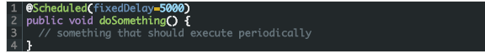

In this case, the duration between the end of last execution and the start of next execution is fixed. The tasks always wait until the previous one is finished.



### **@Async**

This annotation is used on methods to execute each method in a separate thread. The @Async annotation is provided on a method so that the invocation of that method will occur asynchronously. Unlike methods annotated with @Scheduled, the methods annotated with @Asynccan take arguments. They will be invoked in the normal way by callers at runtime rather than by a scheduled task.

@Async can be used with both void return type methods and the methods that return a value. However methods with return value must have a Future typed return values.

## Spring Framework Testing Annotations

### **@BootstrapWith**

This annotation is a class level annotation. The @BootstrapWith annotation is used to configure how the Spring TestContext Framework is bootstrapped. This annotation is used as a metadata to create custom composed annotations and reduce the configuration duplication in a test suite.

### **@ContextConfiguration**

This annotation is a class level annotation that defines a metadata used to determine which configuration files to use to the load the ApplicationContext for your test. More specifically @ContextConfiguration declares the annotated classes that will be used to load the context. You can also tell Spring where to locate for the file.  
@ContextConfiguration(locations={"example/test-context.xml", loader = Custom ContextLoader.class})

### **@WebAppConfiguration**

This annotation is a class level annotation. The @WebAppConfiguration is used to declare that theApplicationContext loaded for an integration test should be a WebApplicationContext. This annotation is used to create the web version of the application context. It is important to note that this annotation must be used with the @ContextConfiguration annotation.The default path to the root of the web application is src/main/webapp.You can override it by passing a different path to the <span class="theme:classic lang:default decode:true crayon-inline">@WebAppConfiguration.

### **@Timed**

This annotation is used on methods. The @Timed annotation indicates that the annotated test method must finish its execution at the specified time period(in milliseconds). If the execution exceeds the specified time in the annotation, the test fails.



### **@Repeat**

This annotation is used on test methods. If you want to run a test method several times in a row automatically, you can use the @Repeat annotation. The number of times that test method is to be executed is specified in the annotation.



### **@Commit**

This annotation can be used as both class-level or method-level annotation. After execution of a test method, the transaction of the transactional test method can be committed using the @Commit annotation. This annotation explicitly conveys the intent of the code. When used at the class level, this annotation defines the commit for all test methods within the class. When declared as a method level annotation @Commit specifies the commit for specific test methods overriding the class level commit.

### **@RollBack**

This annotation can be used as both class-level and method-level annotation. The @RollBack annotation indicates whether the transaction of a transactional test method must be rolled back after the test completes its execution. If this true @Rollback(true), the transaction is rolled back. Otherwise, the transaction is committed.@Commit is used instead of @RollBack(false).

When used at the class level, this annotation defines the rollback for all test methods within the class.

When declared as a method level annotation @RollBack specifies the rollback for specific test methods overriding the class level rollback semantics.

### **@DirtiesContext**

This annotation is used as both class-level and method-level annotation. @DirtiesContext indicates that the Spring ApplicationContext has been modified or corrupted in some manner and it should be closed. This will trigger the context reloading before execution of next test. The ApplicationContext is marked as dirty before or after any such annotated method as well as before or after current test class.

The @DirtiesContext annotation supports BEFORE_METHOD, BEFORE_CLASS, and BEFORE_EACH_TEST_METHOD modes for closing the ApplicationContext before a test.

**NOTE**: Avoid overusing this annotation. It is an expensive operation and if abused, it can really slow down your test suite.

### **@BeforeTransaction**

This annotation is used to annotate void methods in the test class. @BeforeTransaction annotated methods indicate that they should be executed before any transaction starts executing. That means the method annotated with @BeforeTransaction must be executed before any method annotated with @Transactional.

### **@AfterTransaction**

This annotation is used to annotate void methods in the test class. @AfterTransaction annotated methods indicate that they should be executed after a transaction ends for test methods. That means the method annotated with @AfterTransaction must be executed after the method annotated with @Transactional.

### **@Sql**

This annotation can be declared on a test class or test method to run SQL scripts against a database. The @Sqlannotation configures the resource path to SQL scripts that should be executed against a given database either before or after an integration test method. When @Sql is used at the method level it will override any @Sqldefined in at class level.

### **@SqlConfig**

This annotation is used along with the @Sql annotation. The @SqlConfig annotation defines the metadata that is used to determine how to parse and execute SQL scripts configured via the @Sql annotation. When used at the class-level, this annotation serves as global configuration for all SQL scripts within the test class. But when used directly with the config attribute of @Sql, @SqlConfig serves as a local configuration for SQL scripts declared.

### **@SqlGroup**

This annotation is used on methods. The @SqlGroup annotation is a container annotation that can hold several@Sql annotations. This annotation can declare nested @Sql annotations.  
In addition, @SqlGroup is used as a meta-annotation to create custom composed annotations. This annotation can also be used along with repeatable annotations, where @Sql can be declared several times on the same method or class.

### **@SpringBootTest**

This annotation is used to start the Spring context for integration tests. This will bring up the full autoconfigruation context.

### **@DataJpaTest**

The @DataJpaTest  annotation will only provide the autoconfiguration required to test Spring Data JPA using an in-memory database such as H2.

This annotation is used instead of @SpringBootTest

### **@DataMongoTest**

The @DataMongoTest  will provide a minimal autoconfiguration and an embedded MongoDB for running integration tests with Spring Data MongoDB.

### **@WebMVCTest**

The @WebMVCTest will bring up a mock servlet context for testing the MVC layer. Services and components are not loaded into the context. To provide these dependencies for testing, the @MockBean annotation is typically used.

### **@AutoConfigureMockMVC**

The @AutoConfigureMockMVC  annotation works very similar to the @WebMVCTest  annotation, but the full Spring Boot context is started.

### **@MockBean**

Creates and injects a Mockito Mock for the given dependency.

### **@JsonTest**

Will limit the auto configuration of Spring Boot to components relevant to processing JSON.

This annotation will also autoconfigure an instance of [JacksonTester](https://docs.spring.io/spring-boot/docs/current/api/org/springframework/boot/test/json/JacksonTester.html) or [GsonTester](https://docs.spring.io/spring-boot/docs/current/api/org/springframework/boot/test/json/GsonTester.html).

### **@TestPropertySource**

Class level annotation used to specify property sources for the test class.